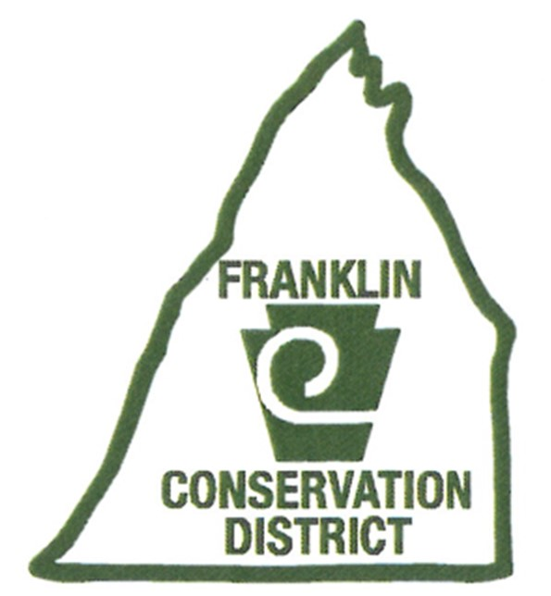
FRANKLIN COUNTY CONSERVATION DISTRICT
JOB DESCRIPTION: Ag Conservation Technician

Job Title: Ag Conservation Technician
Status: Non-Exempt
Reports to: Manager
Revised Date: January 12, 2022

________________________________________________________________________________

Position Summary

The Ag Conservation Technician will provide direct technical assistance and services to owners and operators of Franklin County farms, production agriculture cooperators and other land owners to help solve natural resource concerns in areas of soil conservation and manure and nutrient management. Work includes the administration and implementation of PA’s Nutrient Management Program (Act 38), PA’s Manure Management Program (PA Chapter 91) and PA’s Chapter 102 regulations dealing with Ag Erosion and Sediment Control plans on agriculture operations. This position will also assist with other District programs as required.

Essential Duties

Nutrient & Manure Management Duties and Responsibilities
- Encourage voluntary and mandatory compliance with PA’s Nutrient Management regulations, Act 38 and PA Chapter 91.
- Educate and promote the agronomic environmental benefits of proper nutrient management including developing and providing education and outreach programs that meet the required output measures in the delegation agreements the FCCD has with the State.
- Assist farm operators and Nutrient Management Specialists with implementing the provisions of the Nutrient Management Act and PA’s Manure Management Program. This includes developing MMPs.
- Review and assist with approval/disapproval of submitted nutrient management plans, plan amendments, transfers, manure storage setback waivers and implementation delays, in accordance with the procedures outlined in the NMA regulations and the Administrative Manual.
- Perform Annual Status Reviews of voluntary and concentrated animal operations with approved Nutrient Management Plans (NMPs) to assess plan implementation and to implement BMPs to comply with the NMA regulations.
- Perform on-site visits of those operations considered to be out of compliance with their approved plan or regulations, based on submitted materials.
- Investigate complaints and violations to obtain voluntary compliance and refer those operations to the State Conservation Commission (SCC) or the appropriate agency when compliance cannot be obtained by the District.
- Provide the SCC and DEP with quarterly reports detailing required program activities outlined in the Administrative Manual and Delegation Agreement.
- Maintain files on NMPs and plan amendments submitted for review and approval, including plan implementation information submitted by operators with approved plans as outlined in program requirements.
- Perform other duties as assigned.

Soil Conservation Duties and Responsibilities
- Encourage voluntary and mandatory compliance with PA’s Chapter 102 regulations requiring all farms to have and implement an Ag Erosion and Sediment Control plan.
- Develop Ag E&S plans for farm operations needing plans.
- Assist farm operations with assessment of natural resource problems and develop BMP designs needed to address resource problems.
- Assist agricultural producers and landowners to obtain required permits and other project approvals required for implementation of BMPs.
- Provide information on financial resources (grants, loans and cost share) available to assist ag producers and landowners in the installation of ag conservation BMPs.
- Serve as an interface between ag producers and federal, state and local government agencies.
- Respond to and investigate ag erosion complaints. Generate a report and follow through until matter is resolved or referred to proper agency.
- Perform other duties as assigned.

Grant Administration Duties and Responsibilities
- Assist with BMP design and implementation oversight.
- Enter BMP data into computer tracking programs.
- Perform other duties as assigned.

Required Technical Knowledge, Skills and Abilities
- Knowledge of algebra, geometry and trigonometry.
- Skill in numerical and verbal reasoning.
- Ability to apply the principles and methods of physical sciences to technical engineering programs.
- Ability to read and interpret technical literature, engineering plans, blue prints and tables.
- Ability to perceive mechanical, physical and spatial relationships.
- Knowledge of soils and use of soils maps.
- Knowledge and use of the Penn State Agronomy Guide.
- Ability to learn and use computer programs such as ArcView GIS, MS Outlook, Practice Keeper, RUSEL, PA One Stop, Word, Excel and others to accomplish conservation planning, tracking, record keeping and reporting tasks.
- Ability to interpret rules, regulations, manuals, policies and procedures to implement the Nutrient and Manure Management Programs and Chapter 102 relating to Ag E&S plans.
- Ability to do the field work and to negotiate uneven and rough terrain, including during inclement weather where wet and slippery surfaces are encountered.

Working Conditions
- Work will be performed throughout Franklin County.
- Position includes sitting, standing, bending, lifting and moving intermittingly during work hours.
- Position is subject to frequent interruptions.
- Employee will be involved with Franklin County residents, government agencies/personnel, consultants, contractors and farmers.
- Position occasionally requires work beyond normal working hours and on the weekends and some overnight stays for training and conferences.
- Works indoors with adequate workspace, lighting, temperature, and ventilation.
- Works outdoors in all weather conditions to accomplish the specific responsibilities of the Ag Conservation Technician.
- Travel to training sessions, educational workshops, and other meetings as required.

Specific Requirements
- Must be able to effectively read, write, speak and understand the English language.
- Must possess a valid drivers license and a clean driving record.
- Must possess the ability to make independent decisions when circumstances warrant such action.
- Must possess effective oral and written communication skills.
- Must possess the ability to deal tactfully with constituents, consultants, plan writers, government agencies/personnel, farmers and the general public.
- Must have knowledge of computer operation, audio-visual aide equipment, standard office equipment and digital camera.
- Must possess the ability and the willingness to work harmoniously with professional and non-professional personnel.
- Must have patience, tact, a cheerful disposition and enthusiasm, as well as the willingness to handle a wide range of individuals.
- As a condition of continuing employment and/or retention of the Ag Conservation Technician, the individual must acquire and maintain the Act 38 Certification.

Physical and Sensory Requirements
(With or without the aid of mechanical devices)
- Must be able to move intermittently throughout the day.
- Must be able to see and hear or use prosthetics that will enable these senses to function adequately to assure that the requirements of this position are fully met.
- Must function independently and have flexibility, personal integrity and the ability to work effectively with constituents, personnel, consultants, engineers, contractors, farmers, and support agencies.
- Must be in good health and demonstrate emotional stability.
- Must be able to lift, push, pull and move a minimum of 50 pounds.

Education and Experience
- Individual should have a strong agricultural background with a good working knowledge of crops, soils, animal husbandry, hydrology, land use and geography.
- Bachelor of Arts or Science Degree in Agriculture, Agronomy, Environmental Science or Resource Management, Biology or related field. An equivalent combination of experience, education and training may qualify at the discretion of the Franklin County Conservation District.

Hours of Work
8 hours/shift; 7:00 AM – 3:30 PM; ½ hour unpaid lunch break; 5 days/week, Monday through Friday; full time, occasional weekend and evening coverage.

Accountability
Conservation District Manager

This job description includes a list of all duties and requirements essential to this job function. Excluded are marginal functions which are incidental to the performance of the fundamental job duties. All requirements are subject to possible modifications to reasonably accommodate individuals with disabilities. Some requirements may exclude individuals who pose a direct threat of significant risk to the health and safety of themselves or others.

In no way does this description state or imply that these are the only duties performed. Employees will be required to follow any other job-related instructions to perform any other job-related duties requested by their supervisor. Requirements are representative of minimum levels of knowledge, skills and abilities.

FRANKLIN COUNTY CONSERVATION DISTRICT
JOB DESCRIPTION: Ag Conservation Technician

The Franklin County Conservation District is an equal opportunity employer. All employment decisions are made without regard to race, color, religion, sex, national origin, age, marital status, veteran status or the presence of a non-job-related medical condition or handicap.

I HAVE READ THE ABOVE JOB DESCRIPTION AND FULLY UNDERSTAND THE REQUIREMENTS SET FORTH THEREIN.

I HEREBY ACCEPT THE POSITION OF AG CONSERVATION TECHNICIAN AND AGREE TO ABIDE BY THE REQUIREMENTS AND DUTIES SET FORTH.

I WILL PERFORM ALL DUTIES AND RESPONSIBILITIES TO THE BEST OF MY ABILITY.

___________________________________ ____________________________________
(Signature of Employee) (Date)

___________________________________ ____________________________________
(Signature of Supervisor) (Date)

In compliance with the Americans with Disabilities Act, the District will provide reasonable accommodations to qualified individuals with disabilities and encourages both prospective and incumbents to discuss potential accommodations with the District.

