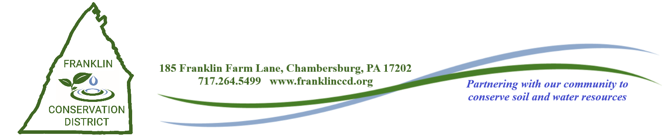**April 10, 2024**

**District Directors Meeting Agenda**

1. CALL TO ORDER and INTRODUCTION OF GUESTS (Roll Call)
2. PUBLIC COMMENT
3. PRESENTATION BY HRG
4. MINUTES
5. TREASURER’S REPORT
   1. February 2024
6. CORRESPONDENCE
7. COOPERATOR AGREEMENTS
   1. Dale Hall – Action
   2. Scott Timmons – Action
   3. Linford Eberly - Action
8. OLD BUSINESS
9. COMMITTEE REPORTS
   1. Golf/Scholarship Committee
   2. Conservation Farmer of the Year Candidate
10. NEW BUSINESS
    1. Nutrient Management/Manure Management Program Delegation

Agreement Proposal – 24/25 – Action

* 1. Wildlife Leadership Academy Donation – Action
  2. DEP Stream Improvement Program Agreement with FCCD – Action
  3. Associate Director Appointment – Action
  4. ACAP Contract – Brandon Winegardner – Action
  5. DGR Lurgan Township Contract – Reed Road - Action

1. NMP’S FOR BOARD ACTION

11.1 Kline’s Hillside Farm - Action

12. AGENCY REPORTS

12.1 NRCS – Justin Atkins

12.2 FSA – Sharon Weigle

12.3 Penn State Extension – Daniela Roland

12.4 Franklin County Planning Commission – Elizabeth Butler

13. DEP FIELD REP REPORT - Chris Santore, DEP Field Representative

14. PACD REPORT

15. FCCD STAFF REPORTS

15.1 MANAGER REPORT – David Stoner

15.2 ASST. MANAGER/AG SPECIALIST REPORT - Scott Metzger

15.3 WATERSHED SPECIALIST REPORT – Emily Young

15.4 AG CONSERVATION TECHNICIAN REPORT - Jennifer Bratthauar

15.5 AG CONSERVATION TECHNICIAN REPORT – Chris Swartz

15.6 102 PROGRAM MANAGER REPORT – Thomas Swartz

15.7 DISTRICT ENGINEER REPORT – John High

15.8 E&S TECHNICIAN REPORT – Brady Byers

15.9 WATERSHED SPECIALIST REPORT – Miranda McCleaf

15.10 AG CONSERVATION TECHNICIAN REPORT – Brandt Wingert

15.11 ADMINISTRATIVE ASSISTANT REPORT – Rhoda Crider

16. STAFF PRESENTATION: Emily Young

17. NEXT MEETING: Wednesday, May 8, 2024 – 8:30 AM

18. PLEDGE OF ALLEGIANCE

19. ADJOURNMENT