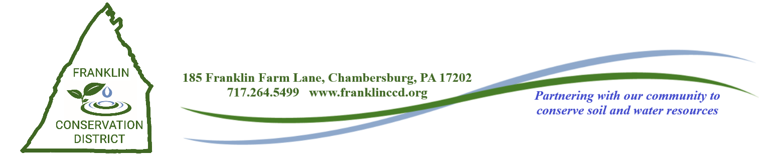**November 8, 2023**

**District Directors Meeting Agenda**

1. CALL TO ORDER and INTRODUCTION OF GUESTS (Roll Call)
2. PUBLIC COMMENT
3. MINUTES
4. TREASURER’S REPORT
   1. September 2023
5. CORRESPONDENCE
6. COOPERATOR AGREEMENTS
   1. Randall Reed
   2. Brad Gamble
   3. Paul Witter

6.4 Lesher’s Poultry

6.5 Benedict’s Produce

6.6 Mercer Vu

6.7 Lance Plessinger

1. OLD BUSINESS
   1. PACD Strategic Planning Grant – Action
2. COMMITTEE REPORTS
3. NEW BUSINESS
   1. CEG Agreement Amendment – Joel & Rebecca Miner – Action
   2. ACAP Agreement – Alan Gift – Action
   3. CEG Agreement – Carl Pugh – Action
   4. RC&D Board Member Appointment – Action
   5. Truck Purchase – Action
   6. ACAP Cover Crop Agreements – Action

10. NMP’S FOR BOARD ACTION

10.1 Steve Priest – Action

10.2 Milton Rotz – Action

10.3 Funk-Family Farm – Jeff & Aretha Funk – Action

10.4 Fahn-Land Farms, LLC – John Fahnestock – Action

10.5 Tim Sollenberger – Action

10.6 Mt. Pleasant Farms (Lynn Eberly) – Action

10.7 Mt. Pleasant Farms (Lynn Eberly) Transfer – Acknowledgement

10.8 Daniel High Transfer - Acknowledgement

11. AGENCY REPORTS

11.1 NRCS – Justin Atkins

11.2 FSA – Sharon Weigle

11.3 Penn State Extension – Daniela Roland

11.4 Franklin County Planning Commission – Elizabeth Butler

12. DEP FIELD REP REPORT - Chris Santore, DEP Field Representative

13. PACD REPORT

14. FCCD STAFF REPORTS

14.1 MANAGER REPORT – David Stoner

14.2 ASST. MANAGER/AG SPECIALIST REPORT - Scott Metzger

14.3 WATERSHED SPECIALIST REPORT – Emily Young

14.4 AG CONSERVATION TECHNICIAN REPORT - Jennifer Bratthauar

14.5 AG CONSERVATION TECHNICIAN REPORT – Chris Swartz

14.6 102 PROGRAM MANAGER REPORT – Thomas Swartz

14.7 DISTRICT ENGINEER REPORT – John High

14.8 E&S TECHNICIAN REPORT – Brady Byers

14.9 ADMINISTRATIVE ASSISTANT REPORT – Rhoda Crider

15. STAFF PRESENTATION: Scott Metzger

16. NEXT MEETING: Wednesday, December 13, 2023

8:00 AM – Director Breakfast

8:30 AM – December Meeting

17. PLEDGE OF ALLEGIANCE

18. ADJOURNMENT